Hot a static website on Azure

1. Sign in to the [Azure portal](https://portal.azure.com/) to get started.
2. Locate your storage account and display the account overview.
3. Select **Static website** to display the configuration page for static websites.
4. Select **Enabled** to enable static website hosting for the storage account.
5. In the **Index document name** field, specify a default index page (For example: index.html).

The default index page is displayed when a user navigates to the root of your static website.

1. In the **Error document path** field, specify a default error page (For example: 404.html).

The default error page is displayed when a user attempts to navigate to a page that does not exist in your static website.

1. Click **Save**. The Azure portal now displays your static website endpoint.

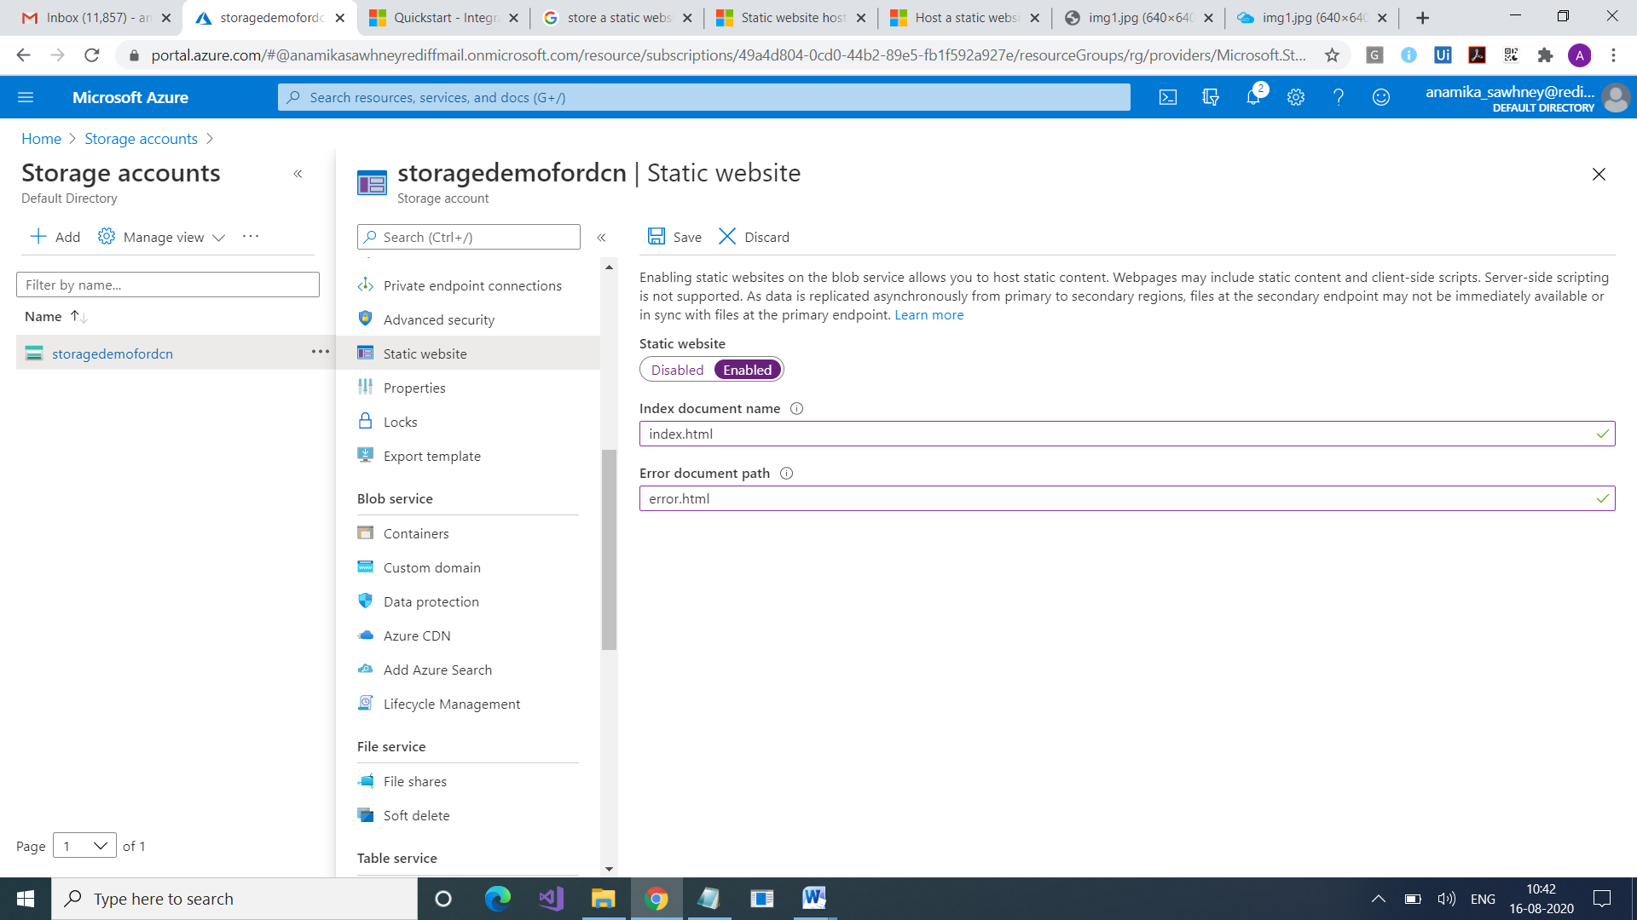

## Now Upload files

you can also use the version of [Storage Explorer](https://azure.microsoft.com/features/storage-explorer/) that runs outside of the Azure portal. You could use [AzCopy](https://docs.microsoft.com/en-us/azure/storage/common/storage-use-azcopy-v10), PowerShell, CLI, or any custom application that can upload files to the **$web** container of your account

You will see $web and $log containers added in the storage account

Add your pages to $web container

